Supporting Information

A PCR-free Fluorescence Strategy for Detecting Telomerase Activity via Double Amplification strategy
Xiafei Zhang, Rui Cheng, Zhilu Shi and Yan Jin*
Key Laboratory of Applied Surface and Colloid Chemistry, Ministry of Education, Key Laboratory of Analytical Chemistry for Life Science of Shaanxi Province, School of Chemistry and Chemical Engineering, Shaanxi Normal University, Xi′an 710062, China

*Corresponding author: Prof. Yan Jin, Key Laboratory of Applied Surface and Colloid Chemistry, Ministry of Education, Key Laboratory of Analytical Chemistry for Life Science of Shaanxi Province, School of Chemistry and Chemical Engineering, Shaanxi Normal University
Email: jinyan@snnu.edu.cn, Fax: 86-29-81530727, Tel: 86-29-81530726
Table S1. Oligonucleotides used in this study.
Name | Sequence(5′-3′)
cTSDNA | CATCTCTTCTCTAACCCTAACCCTAACCCTAACCCTAACTCTGCAG
Trigger DNA (t-DNA) | CTGCAGAGTTGCTGAGGAGAAGAGATG
Molecular beacon (MB) | FAM -GAGTTGCACTACTTCTCCTCAGCAACTC -BHQ
TS primer | AATCCGTCGAGCAGAGTT
ACX | GCGCGGCTTACCCTTACCCTTACCCTAACC
CST | AATCCGTCGAGCAGAGTTAGGGTTAGGGTTAGGGTTAGGGTTAG
All of the oligonucleotides used in this paper were synthesized from Sangon Biotechnology Inc. (Shanghai, P. R. China). They were all purified by reverse-phase high-performance liquid chro-matography (HPLC). The oligonucleotide stock solutions were prepared with Tris–HCl buffer (20 mM Tris-HCl, pH 7.4) and stored at 4℃. CST is the chemically synthesized telomerase product. ACX as linear reverse primer in the telomeric repeat amplification protocol (TRAP) have a 6 bp ‘anchor’ at the 5′-end which is neither telomeric nor complementary to telomeric sequences and can result in a significant reduction in primer dimer PCR artifact formation.

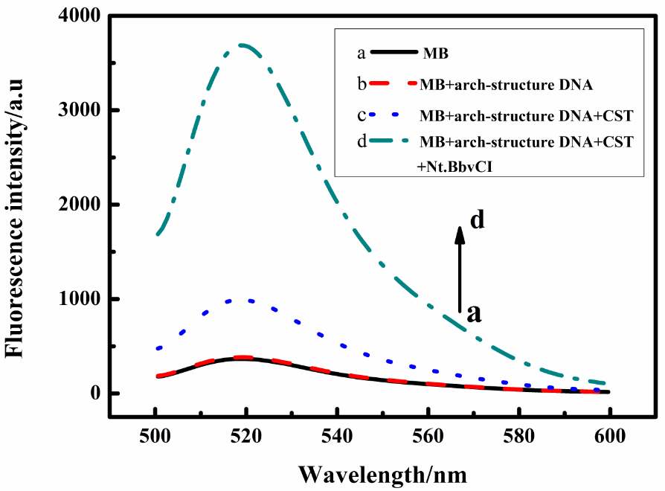
Figure S1. Fluorescence spectra of molecular beacon MB under different conditions. The concentration of MB, arched structure DNA probe, CST and Nt.BbvCI were 300 nM, 100 nM, 100 nM and 20 U/ml, respectively.

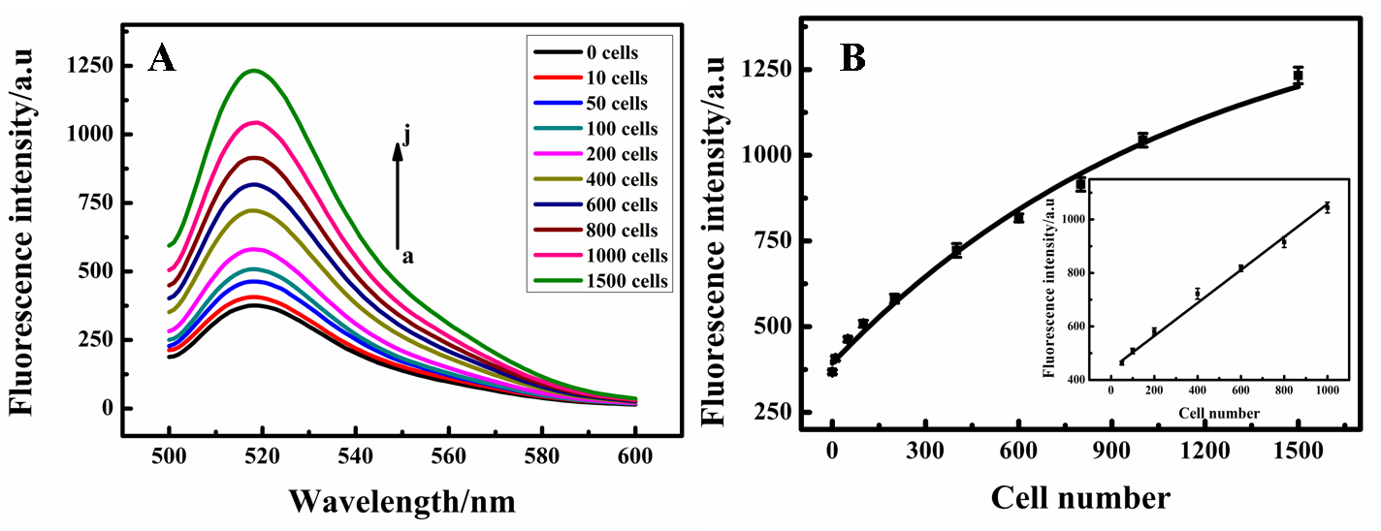
Figure S2. (A) Fluorescent spectra for different number of CCRF-CEM cells. The curves from bottom to top represent the telomerase activity equivalent to the number of CCRF-CEM cells: 0, 10, 50, 100, 200, 400, 600, 800, 1000, 1500 respectively. (B) Calibration curve of the sensor, where the definition of signal is the same as that in (A). The insert is the amplification of the dots 3–9. The concentrations of molecular beacon (MB), TS, arched structure DNA probe and Nt.BbvCI were 200 nM, 20 nM, 100 nM and 15 U/ml, respectively.
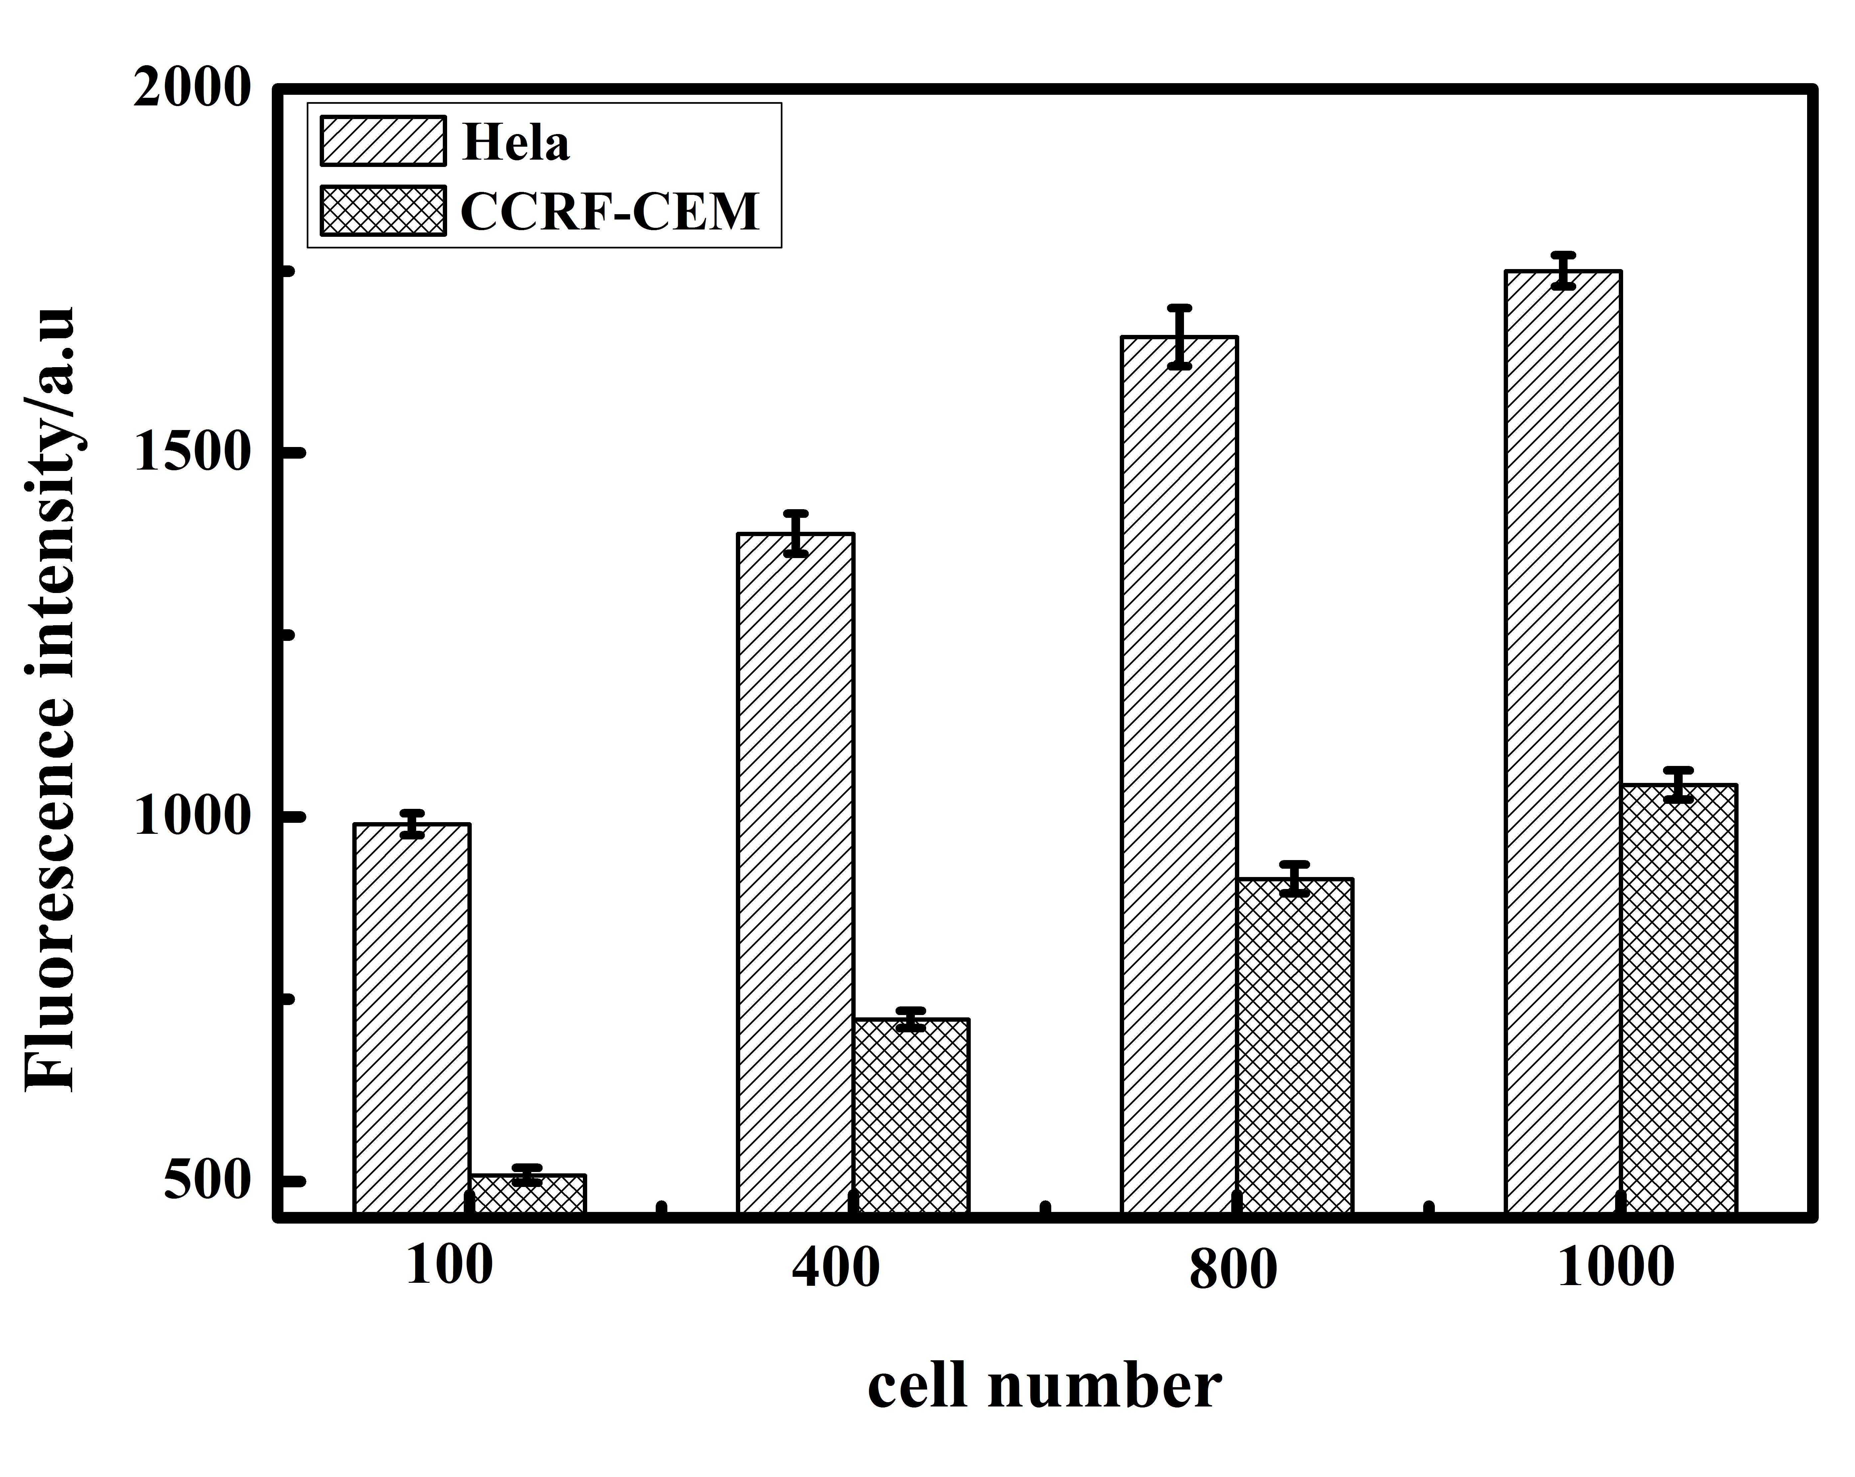
Figure S3. Comparison of the telomerase activity in HeLa cells (black column) and CCRF-CEM cells (red column).
Table S2. Comparison of different assays for detecting telomerase activity
Method | Strategy | Time (min) | Sensitivity (cells) | Selectivity
TRAP assay (1) | AuNP-modified TRAP assay | ~2.5 h | 10 | good
Chemiluminescence (2) | G-quadruplex-hemin DNAzyme based assay | >40 h | 100 | good
Fluorescence (3) | T7 exonuclease-assisted target recycling amplification assay | ~4 h | 5 | good
Fluorescence (4) | Exponential isothermal amplification of telomere repeat assay | ~25 min | 1 | good
Fluorescence (5) | DNAzyme-based amplification assay | Not mentioned | 200 | good
Fluorescence (6) | Cascade isothermal signal amplification assay | ~3 h | 3 | good
Fluorescence (7) | Label-free assay by using quadruplex-selective dye | ~2 h | 1 | good
Chemiluminescence (8) | Two-stage isothermal amplification-mediated assay | ~1h | 1 | good
Chemiluminescence (9) | Catalytic beacons based assay | Not mentioned | 500 | Not mentioned
Electrochemiluminescence (10) | TRAP and magnetic beads based assay | ~1.8 h | 10 | good
Electrochemiluminescence (11) | Magnetic bead and nanoparticle based amplification assay | ~2.5 h | 100 | good
Fluorescence（this paper） | PCR-free and double amplification fluorescence assay | ~1.5 h | 5 | good

Notes and references
- Xiao, Y., Dane, K.Y., Uzawa, T., Csordas, A., Qian, J., Soh, H.T., Daugherty, P.S., Lagally, E.T., Heeger, A.J., Plaxco, K.W., 2010. J. Am. Chem. Soc. 132, 15299–15307.
- Li, Y., Li, X., Ji, X., Li, X., 2011. Biosens. Bioelectron. 26, 4095–4098.
- Wang, H.B., Wu, S., Chu, X., Yu, R.Q., 2012. Chem. Comm. 48, 5916–5918.
- Tian, L.L., Weizmann, Y., 2013. J. Am. Chem. Soc. 135, 1661–1664.
- Tian, T., Peng, S., Xiao, H., Zhang, X.E., Guo, S., Wang, S.R., Zhou, X., Liu, S.M., Zhou, H., 2013. Chem. Commun. 49, 2652–2654.
- Zhao, Y.X., Qi, L., Chen, F., Zhao, Y., Fan, C.H., 2013. Biosens. Bioelectron. 41, 764– 770.
- Quach, Q.H., Jung, J.Y., Kim, H.R., Chung, B.H., 2013. Chem. Commun. 49, 6596–6598.
- Wang, L.J., Zhang, Y., Zhang, C.Y., 2013. Anal. Chem. 85, 11509–11517.
- Xiao, Y., Pavlov, V., Niazov, T., Dishon, A., Kotler, M., Willner, I., 2004. J. Am. Chem. Soc. 126, 7430–7431.
- Zhou, X.M., Jia, L., 2008. Chinese Chemical Letters. 19, 699–702.
- Zhou, X.M., Xing, D., Zhu, D.B., Jia, L., 2009. Anal. Chem. 81, 255–261.

